Q1.Discuss Expectation Maximization algorithm with the help of flow charts.
Ans –
- In Machine Learning variables can be categorized into two types :
- Observable variables – Those variables whose values are directly known.
- Unobservable variables – Those variables whose values are not directly known but can be inferred from observable variables and are also known as latent variables.
- Expectation Maximization (EM) algorithm is used to predict the values of such unobserved / latent variables with the underlying assumption that the general form of probability distribution governing these latent variables is known to us.
- Therefore, EM is a latent variable model meaning it consists of both observable & unobservable variables.
- The EM Algorithm aims to use the available observed data to estimate the missing data of latent variables & then using that data to update the values of the parameter in the maximization step in an iterative process.
Algorithm :-
- Initialization Step :- In this step, we initialize the parameter values with a set of initial values, then give the set of incomplete observed data to the system with the assumption that the observed data comes from a specific model i.e., probability distribution.
- Expectation Step :- In this step, by using the observed data to estimate or guess the values of the missing or incomplete data. It is used to update the variables.
- Maximization Step :- In this step, we use the complete data generated in the “Expectation” step to update the values of the parameters i.e, update the hypothesis.
- Checking of convergence step :- Now, in this step, we check whether the values are converging or not, if yes, then stop otherwise repeat these two steps i.e. , the “Expectation” step and “Maximization” step until the convergence occurs.
Flowchart :-
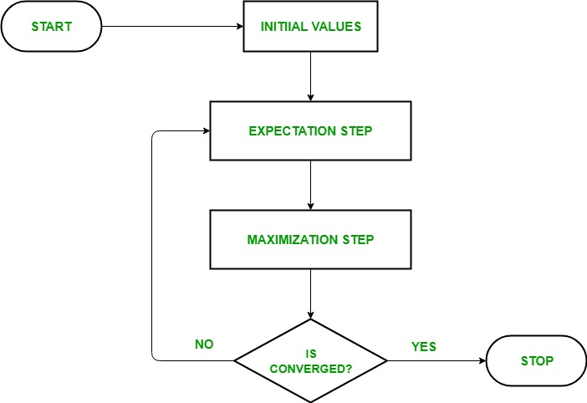
Usage of EM algorithm –
- It can be used to fill the missing data in a sample.
- It can be used as the basis of unsupervised learning of clusters.
- It can be used for the purpose of estimating the parameters of Hidden Markov Model (HMM).
- It can be used for discovering the values of latent variables.
Advantages of EM algorithm –
- It is always guaranteed that likelihood will increase with each iteration.
- The E-step and M-step are often pretty easy for many problems in terms of implementation.
- Solutions to the M-steps often exist in the closed form.
Disadvantages of EM algorithm –
- It has slow convergence.
- It makes convergence to the local optima only.
- It requires both the probabilities, forward and backward (numerical optimization requires only forward probability).

Q.2 Describe the process of data science in detail.
Ans :- Data Science is a systematic process used by Data Scientists to analyse, visualize and model large amounts of data. It helps data scientists use the tools to find unseen patterns, extract data, and convert information to actionable insights that can be meaningful to a company or organization.
Data Science Process:-
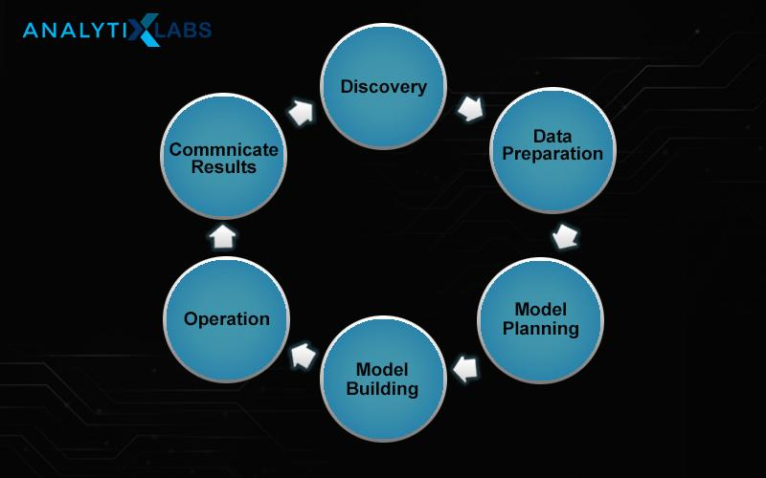
Steps in Data Science Process :-
Step 1: Discovery
Before solving a problem, the pragmatic thing to do is to know what exactly the problem is. Data questions must be first translated to actionable business questions.
A great way to go through this step is to ask questions like:
- Who the customers are?
- How to identify them?
- What is the sale process right now?
- Why are they interested in your products?
- What products they are interested in?
At the end of this step, we must have as much information at hand as possible.
Step 2: Data Preparation
In this stage, we investigate, preprocess and condition data for modelling. We perform information cleaning, changing, and visualization. This assists us to spot the exceptions and build up a relationship between the factors. Once we have got cleaned and arranged the information, it’s time to do exploratory analytics on it.
Step 3: Model Planning
Here, we decide the strategies and methods to draw the connections between factors. These connections will set the base for the calculations which we can execute within the following stage. We apply Exploratory Data Analytics (EDA) utilizing different factual equations and visualization apparatuses
Step 4: Model Building
In this stage, we create datasets for training and testing purposes. We analyze different learning procedures like classification, association, and clustering and at last, actualize the most excellent fit technique to construct the show.

Step 5: Operation
This step will involve mathematical, statistical, and technological knowledge. We must use all the data science tools to crunch the data successfully and discover every insight we can. We might have to prepare a predictive model that can compare our average customer with those who are underperforming. We might find several reasons in our analysis, like age or social media activity, as crucial factors in predicting the consumers of a service or product.

Step 6: Communicate Results
Presently, it is critical to assess the outcome of the objective. So, within the final stage, we recognize all the key discoveries, communicate to the partners and decide in the event that the outcomes about the venture are a victory or a disappointment based on the criteria created in Stage 1.

